# Exercise 1

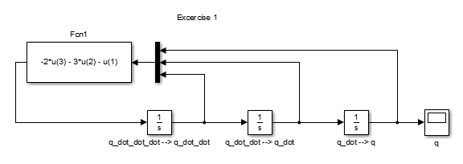

# Exercise 2

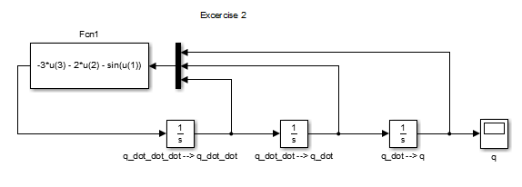

# Exercise 3a

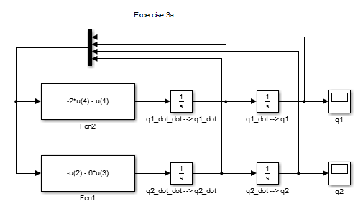

# Exercise 3b

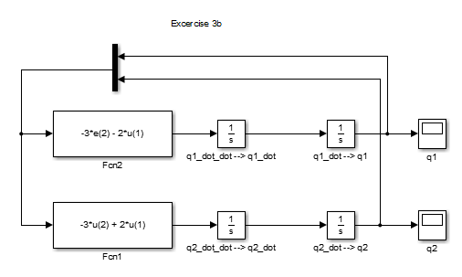

# Exercise 3c

# C:\GitHub\classwork\AAE 421\hw3\5.png

# Exercise 4

(done by hand)

# Exercise 5

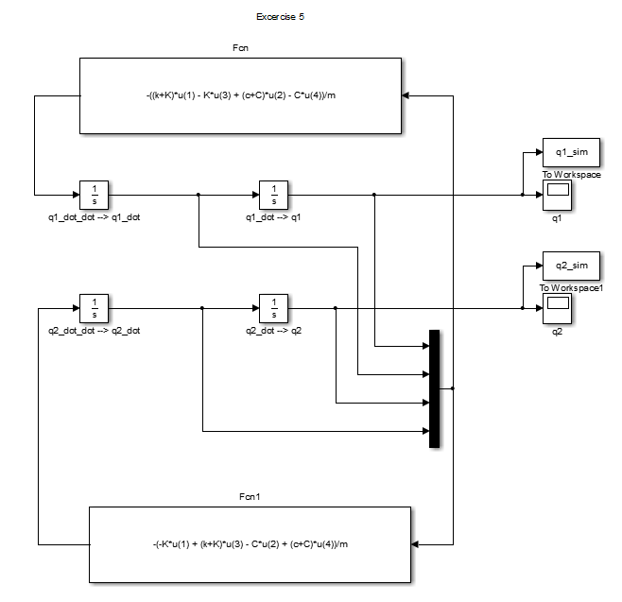

# Exercise 5 part (i)

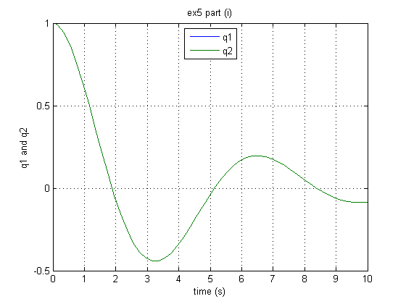

Please note that curves are identical and overlap here

# Exercise 5 part (ii)

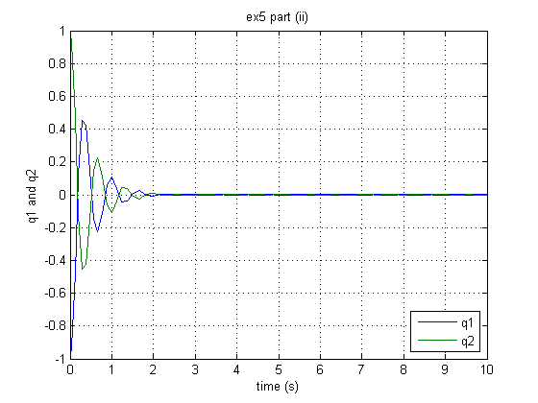

# Exercise 5 part (iii)

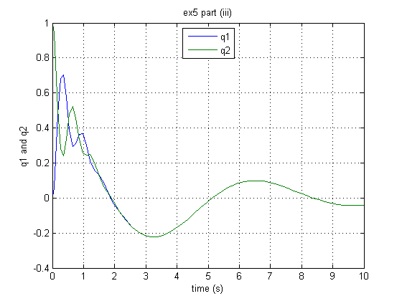

# Exercise 6 part (a)

%given

g = 0.81;

m = 0.1;

K = 1;

k = 0.001;

w = 10;

%equilibrium value of q

q_equib = (m*g-w^2*k)/K

MATLAB output:

q_equilibrium = -0.0190 [m]

# Exercise 6 part (b)

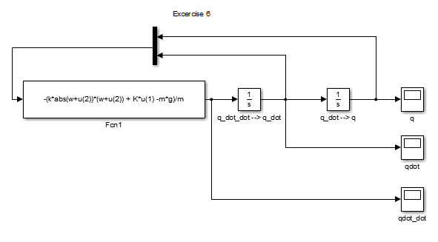

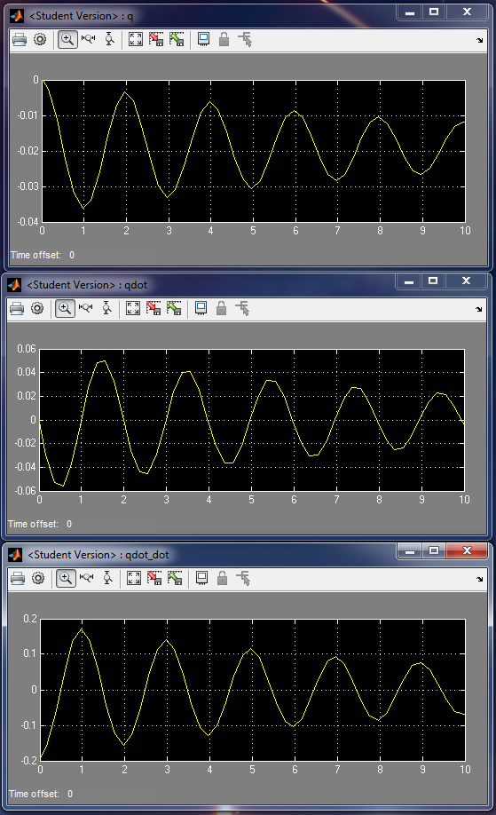

q dot_dot(m/s^2)

qdot (m/s)

q (m)

Time (s)

Time (s)

Time (s)